ODISHA UNIVERSITY OF TECHNOLOGY AND RESEARCH
Techno Campus, Ghatikia, P.O.- MahalaxmiVihar
BHUBANESWAR-751029 ODISHA, INDIA

No:. 3464/OUTR Dated: 07.11.2023
TENDER CALL NOTICE
Sealed tenders in Two Bid system are invited from reputed Original Equipment Manufacturers (OEM) / Registered Firms / Agencies for the Supply, installation, testing and commission of following Items for School of Mechanical Sciences OUTR, Bhubaneswar.
A | 1.Chamber with Data Acquisition System
A | 2.Wind Speed Sensor / Anemometer
A | 3. Humidity Sensor
A | 4.Thermocouple Sensor
A | 5. Solar Radiation Sensor + Light Sensor with power supply unit output : 4-20mA/0-10V
A | 6.Halogen Light: Minimum 2000Watt
B | 7.Pyranometer
The sealed tender will be received by speed post/registered post only. The authority will not be held responsible for any postal delay. The tender document received after the scheduled date and time will not be accepted. The last date of tender submission is 27.11.2023 up to 4:00 P.M. The tender bid documents with other details are to be downloaded from the Website: www.outr.ac.in. The authority reserves the right to reject/cancel the tenders in whole or in part without assigning any reason thereof.
Sd/-
REGISTRAR

BIDDING DOCUMENTS AND INSTRUCTION FOR SUPPLY OF EQUIPMENTS UNDER AICTE RPS PROJECT

No:. 3464/OUTR Dated: 07.11.2023



ODISHA UNIVERSITY OF TECHNOLOGY AND RESEARCH
Techno Campus, Ghatikia, P.O:-MahalaxmiVihar
BHUBANESWAR-751029 ODISHA, INDIA

INVITATION FOR BIDS

Registrar in-charge, ODISHA UNIVERSITY OF TECHNOLOGY AND RESEARCH, Bhubaneswar, invites sealed tenders in Two Bid system from eligible bidders for Supply, installation, testing and commission of following items for AICTE RPS Project (School of Mechanical Sciences),OUTR, Bhubaneswar.
A | 1.Chamber with Data Acquisition System
A | 2.Wind Speed Sensor / Anemometer
A | 3. Humidity Sensor
A | 4.Thermocouple Sensor
A | 5. Solar Radiation Sensor + Light Sensor with power supply unit output : 4-20mA/0-10V
A | 6.Halogen Light: Minimum 2000Watt
B | 7.Pyranometer
Interested eligible Bidders may obtain detailed information and a list of items with technical specifications from the website www.outr.ac.in

Particulars about the submission of the bidding document are as follows:

- Price of bidding document: Rs. 6000/- (service tax is included) (non-
refundable) in shape of Demand Draft in favor of The Registrar, Odisha University of Technology and Research, Bhubaneswar drawn in any Nationalized Bank payable at Bhubaneswar.

(b) The bidder has to submit a Demand Draft / Banker’s Cheque / Pay order of Rs.
10000/ -in favour of The Registrar, Odisha University of Technology and
Research, Bhubaneswar drawn in any Nationalized Bank payable at
Bhubaneswar towards EMD.
(c) First date of availability of Bidding Document on the website: 07.11.2023

(d) Last date and time for submission of bids: 27.11.2023 up to 4:00 PM

(e) Time and date of opening of technical bids: 28.11.2023 at 03:00 PM.
(f) Time and date of opening of financial bids: Will be communicated to the technically successful bidders
(g) Time period for completion: 04 weeks from the date of work/Purchase order issued.

(h) The authority reserves the right to reject any or all the bids without assigning
any reason thereof.
(i) Other details can be seen in the detailed tender call notice through
University site www.outr.ac.in.
(j) For any queries on detailed condition of Tender please contact to Electrical Maintenance, Room No. C-216 of OUTR, Mob.No-9439858119 during the office hours only.
(k) Place of opening of bids: HoS Chamber, School of Mechanical Sciences

ODISHA UNIVERSITY OF TECHNOLOGY AND RESEARCH
(Formerly College of Engineering & Technology, Bhubaneswar)
Techno Campus, Ghatikia, P.O.: Mahalaxmivihar,
BHUBANESWAR -751029, ODISHA

(l) Address for communication: Office of the Registrar

ODISHA UNIVERSITY OF TECHNOLOGY AND RESEARCH
(Formerly College of Engineering & Technology, Bhubaneswar)
Techno Campus, Ghatikia, P.O.: Mahalaxmivihar,
BHUBANESWAR -751029, ODISHA
Email id: registrar@outr.ac.in

Sd/-
REGISTRAR

Detailed Tender document and conditions of Bid:

The financial Bid & Technical Bid must be enclosed separately.
The Tender documents can be downloaded from our website www.outr.ac.in, and the bidder has to submit a separate draft of Rs.6000/- (non-refundable) towards cost of tender document and a draft of Rs 10000/- towards EMD in favor of The Registrar, Odisha University of Technology and Research, Bhubaneswar drawn in any Nationalized Bank payable at Bhubaneswar along with the submitted tender, otherwise the offer submitted by the bidder will be summarily rejected.

1. Eligibility of Bidder and General Instructions:

1.1 Eligibility:
Those who fulfill the following criteria are eligible to participate in the tender.
1.1.1 The bidder is preferably be a reputed Original Manufacturer/Authorized Distributor, who should provide the documents relating to their Manufacturing Capabilities/services as follows.
  - The bidder should possess valid GSTIN No.
  - The Company should be registered with Tax Department.
  - The company must have cleared all Tax payments (ST & GST) up to date. Attested copies of all Tax Clearance Certificate or non-assessment certificates from the concerned Tax Authority valid up to date and attested copies of Income Tax Clearance Certificates or non-assessment certificates, as the case may be, from the competent authority, up-to-date and Income tax PAN and GSTIN No. must be enclosed along with the Tender documents.
  - If the bidder is an Authorized Distributor of a reputed manufacturer, a necessary authorization certificate to this effect must be enclosed.
  - All after-sales, support should be provided directly by the supplier/bidder only.
  - The bidder must provide evidence of successful execution of supply orders of equipments of similar specification with installation and successful after-sales support in reputed organizations like Central govt., state govt. Hospitals, Institutes, PSUs etc., in the last 3 years.
  - The bidder must have the willingness to provide comprehensive maintenance support of the equipments supplied.
  - The bidder should not have been blacklisted by any organization.

1.2 General Instructions:
The selection for procurement of the equipments will be as the basis of quality and cost of the equipments. The items rates in A and B in the financial bid will be evaluated separately. In this context decision of the Technical Committee is final based on documentary evidence and /or actual physical verification (as the case may be).
  - Submission of more than one bid by a particular bidder under different names is strictly prohibited. In case it is discovered later on that, this condition is violated, all the bids submitted by such bidder(s) would be rejected or the contract canceled.
  - The bidder should mention in the tender paper the location of its service center for Bhubaneswar.
  - All offers should be in English, and the price quoted for each item should be firm.
  - Warranty period, delivery period, and After-Sale-Service conditions, etc., are also to be clearly indicated.
  - The rates, the terms & conditions of the offer will remain valid for three months from the date of opening of the tender, and no change or alteration of the rate will be acceptable on any account.
  - Submitted tender forms with overwriting/erased/illegible or correction of specifications and rates will be rejected.
  - Request from a bidder in respect of additions, alterations, modifications, corrections, etc., of either terms & conditions or rate after the opening of the bid will not be considered. However, negotiation may be made before finalization of the tender.
  - Bidders shall carefully examine the bid documents and fully inform themselves of all the conditions, which may in any way affect the work or the cost thereof.
  - If a bidder finds discrepancies or omissions in respect of the specification or other documents and any doubt as to their meaning, he should at once notify the purchaser and obtain clarification in writing.
  - This, however, does not entitle the bidder to ask for time beyond the due date fixed for receipt of tenders.
  - The bidder must also specify the time frame to repair/replace in the event of a failure of function on damage or else penalty will be imposed thereof.
  - Verbal clarification and/or information given by the purchaser or its employees or representatives shall not be binding on the purchaser.
  - Submission of a sealed bid will carry with the implication that the bidder agrees to abide by the conditions laid down in the detailed particulars of the bid notice.
  - Conditional offers and offers qualified by vague and indefinite expressions, such as ‘subject to immediate acceptance’ and ‘subject to prior sale’, etc. will not be considered.
  - While bids are under consideration, bidders and their representatives or other interested parties are advised to remain away from contacting by any means, to the purchaser's personnel or representatives on matters relating to the tenders under study.
  - The purchaser, if necessary, will obtain clarification on bids by requesting such information from any or all the bidders either in writing or through personal contact as may be necessary.
  - The bidder will not be permitted to change the substance of his offer after the tenders have been opened.
  - In the event of non-compliance with this provision, the bid is liable to be rejected.
s) All the documents submitted must be in the papers showing signature of the bidder on the printed office name of the bidder on the official seal.

1.3 Procedure for Submission of Tenders:
a) The bidders must submit their bids as required in two parts in separate sealed covers prominently super scribed as Part-I “Technical Bid” and Part-II “Financial Bid” and also indicating on each of the covers the “Tender call Notice Number & Date” and due date and time of submission as mentioned in Tender Call Notice.

Part-I (Technical Bid)
Except the price schedule, all other documentsin support of eligibility conditions as mentioned in para 1.1, i.e., details of technical specifications (Technical Bid Annexture-I duly filled), separate DD of Rs. 6000/- towards tender paper cost and Rs. 10000/- towards EMD, leaflet, Copy of Firm Registration Certificate from the competent authorities, All Tax Clearance certificates, PAN Card copy, proof of GSTIN No., list of clients, authorization certificate from Manufacturer, warranty/guarantee certificates, OEM inspection certificate/any govt. accredited organizations in case of Dealer, etc. along with tender document duly signed by the authorized person in each page shall be covered in Part-I (Technical Bid).

Part-II (Financial Bid)
All indications of price shall be given in Part-II (Financial Bid, A and B) Annexture-II
c) Both sealed covers Part-I “Technical Bid” and Part-II “Financial Bid” should placed in a third cover along with requisite EMD & cost of Tender documents (separately in the form of DD drawn in favor of REGISTRAR, ODISHA UNIVERSITY OF TECHNOLOGY AND RESEARCH, Bhubaneswar at any Nationalized Bank payable at Bhubaneswar), others requisite supporting documents, etc. and sealed. The sealed cover containing tender documents, as per the procedure indicated above, should be submitted by Speed Post /Registered Post to the office of the Registrar, ODISHA UNIVERSITY OF TECHNOLOGY AND RESEARCH, Techno Campus, Mahalaxmi Vihar, Bhubaneswar-751029 within the due date and time as stipulated in tender. No hand or Courier delivery is accepted. The sealed envelope must show the name of the bidder and his address and should be superscribed as “Tender for Supply of AICTE RPS project equipments”.
d) All the documents must be submitted in a sequential manner along with separators/flags and check sheet to help in the quick scanning of the topics. Wherever possible, data in tabular form should be given.

2. Requirements by Bidder before Supply:

2.1 Rating Plate, Name Plate, and Labels:
Rating Plate, Name Plate and Labels: Each of the equipment is to have permanently attached to it, a rating plate of noncorrosive material in a conspicuous position, upon which the total specifications along with the manufacturer’s name, address, etc. are to be engraved.

2.2 Packaging:
All the equipment shall be suitably protected, covered in water -proof packing and crated to prevent damage or deterioration during transit and storage till the time of installation at no extra cost. The supplier shall be responsible for any loss or damage caused during transportation, handling, or storage till their successful installation.

2.3 Inspection:
- All materials / equipment shall be inspected and tested for completeness, proper assembly, operation, cleanliness and state of physical condition, compatibility, and performance as per quoted specification.
- The test shall be conducted, reported and certifications to be provided by the tenderer.
- The tenderer shall provide all test and measuring equipment/tools required for inspection / testing.
- The cost of all such tests shall be borne by the Tenderer.
- OUTR reserves the right to reject any equipment if it does not comply with the specifications during site testing, installation, and commissioning stage.
- Inspection & testing would be conducted, jointly, at various stages as applicable during unpacking, installation, and commissioning of respective equipment / components at the installation site before issue of successful performance report..

3. Requirements by Tender after Supply:

3.1 Supply:
- The material should be delivered by the supplier at School of Mechanical Sciences, Odisha University of Technology and Research, Techno Campus, P.O. Mahalaxmi Vihar, Ghatikia, Bhubaneswar – 751029, Odisha.
- The items should be supplied directly having passed all tests successfully with Certifications as required.
- The equipment should conform to the latest relevant National/ International standards and shall be compatible and complete in all respect.
- Any component, fitting etc. which may not have been specifically mentioned in the specifications but which are usual and necessary for the equipments, shall be supplied by the bidder at no extra cost.
- In case, articles are found damaged in transit or found short at the time of delivery the full cost of the same will be deducted from the bill of the supplier in case the supplier does not replace the stock within a week from the date of the complaint.
- The articles ordered must be supplied in one lot within 4 (four) weeks of placing of the order.
- OUTR reserves the right to procure the materials from alternative sources at the risk and cost of the successful tenderer giving 15 days’ notice.
- Any increase in tax and duties after expiry of delivery period will be borne by the supplier.
- In case the items supplied by the supplier are found not up to the specification shall be rejected.
- The supplier will be intimated to take back the stocks at his own cost within three days from the date of rejection and to replace the same within 7 days, failing which the EMD will be invoked in addition to taking legal actions.
- Imported consignment, if any, should be destined to “The Head of School, School of Mechanical Sciences, Odisha University of Technology and Research, Techno Campus, P.O. Mahalaxmi Vihar, Ghatikia, Bhubaneswar – 751029, Odisha, India through nearest custom clearing Airport (Bhubaneswar Air Port).
- The suppliers shall be responsible for releasing the consignments from the carriers/transporters.
- The equipment shall be delivered and installed at site at the cost of the tenderer.
- All taxes, levies, surcharges including the customs clearance and handling freight and insurance should be paid and handled by the tenderer.

3.2 Installation and Commissioning:
Installation and Commissioning shall include the following:
a) Installation and Testing of the Equipment, Machineries etc. should be done by the tenderer at no extra cost.
b) It will be the responsibility of the tenderer to provide all necessary spares and consumables, which may be required during installation and commissioning, at no extra cost to purchaser.
c) The tenderer is to bring their own testing and measuring instruments required for installation, testing, commissioning, which can be taken back after completion.
d) Installation must complete within 15 days after delivery on site.
e) The tenderer should provide all necessary accessories/ components for running of the machine during commissioning..

3.3 Documentation:
Detailed technical manuals, handbooks, drawings, Warranty card and Factory Quality Assurance checklist, test results and any other certifications mentioned in the Technical specifications shall be supplied along with the consignment.
Supplied manuals/handbooks must cover detailed technical specifications and installation, operation, maintenance and System Safety procedures.
The receipts for taxes paid, if any, for the supplied materials should also be submitted

3.4 Trial Operation and Performance Guarantee Test:

After successful completion of Installation and Commissioning of the equipment, a 7-day continuous trial operation putting those on optimum use shall be conducted by the tenderer at site, during which the performance of the equipment shall be demonstrated for trouble-free continuous operation, meeting the specified standards and proper training shall be imparted to two persons of the purchaser. b) During trial operation, tenderer shall do all necessary adjustments required to ensure the performance as per the acceptable level. c) In case, guaranteed performance is not established, the tenderer shall be given opportunity to rectify/replace the equipment/components, and restart the 7 days continuous trial operation, at the risk and cost of the tenderer

On-Site Warranty:
The equipment may be used continuously. The reliability and safety of the total installed system and trouble-free operation are, therefore, of prime importance. The supplied devices/equipment and components shall be covered under Two-years or more comprehensive on-site warranty from the date of issue of completion of installation and Performance Guarantee Report. b) During the period of warranty, it shall be the responsibility of the tenderer to provide all essential spares and consumables, which may be required for maintenance and trouble-free operation of the devices / components at the tenderer’s cost. c) Software, if any, is to be tested with at least one-year warranty for trouble free operation.

3.6 After-Sales Service:
During the warranty period and subsequently, after signing of Agreement for CMC the bidder shall attend to the problems reported by the users of OUTR on a priority basis.
For any problem reported, the bidder shall attend and rectify the problem within 02 (TWO) days or provide a standby system of the similar configuration.
The report on any problem will be informed through phone or fax or E-mail which shall be given by the bidder.
The bidders will be fully responsible to provide maintenance service, in case of any negligence, in providing the service by the bidder.
- Penalty of 1% of the contract value will be collected.
- Bidder will be prohibited to execute further works in OUTR.
On failure to comply with those instructions, the EMD/Performance security deposited for the warranty period shall be invoked.

4. Financial Terms:

4.1 EMD
Earnest money Deposit of Rs.10,000/- for the entire work must accompany with the tender paper. This deposit shall be in shape of DD/Banker’s cheque pay order drawn in any Nationalized Bank in favour of the Registrar, OUTR, Bhubaneswar. No other form of earnest money deposit is acceptable. Tender not accompanied with earnest money deposit shall be rejected as non-response. If during the tender validity period the tenderer withdraw his tender, the earnest deposit shall be forfeited. The earnest money will be retained in the case of successful tenderer and will be dealt with as per the terms and conditions of OGFR rules. The earnest money of the successful tenderers shall be retained and the EMD given by the un-successful tenderers shall be refunded within 15 days after acceptance of tender and agreement signed.

4.2 Performance Security Deposit
In case of successful Bidder EMD will be kept as Performance Security Deposit and will be refunded after the expiry of stipulated warranty periods from the completion date of installation and commissioning on satisfactory performance of the all eqipments.

4.3 Prices:
Price quoted should be FOR ODISHA UNIVERSITY OF TECHNOLOGY AND RESEARCH, Bhubaneswar only. Tax components as applicable, should be mentioned clearly in the financial bid.
Price should be quoted for unit/set item). The prices of items in A and B of financial bid will be evaluated separately.
Purchase order will be placed as a single lot for all the items together.

Payments:
100 % Payment of the ordered value will be made after completion of delivery & successful installation of the equipments at required OUTR sites subject to submission of the satisfactory performance report by the competent authority after joint verification by OUTR authority & supplier.

4.5 Rate Contract with DGS&D or any other Government Organisation:
In case the bidder has entered into a Rate Contract with DGS&D or any other Government organization such as EPM, rate contract preference, number & copy of rate contract have to be submitted along with tender.

5. Instruction to the Bidder:
Some of the minimum specifications specified may be redundant, obsolete, or incompatible, and in these cases, quote the particulars of correct specification of latest trend and technology.
Higher specifications instead of minimum specifications are allowed if a minimum specification is not available, obsolete or incompatible.
Otherwise, model with higher specification should be in addition to the model with minimum specifications.
Specify the brand name and full model name and number for each offer.
Include the printed catalog and pricelist if any, for items.
Specify the list of Accessories required along with each of the items.
Quote the additional price of the accessories; only those, which are fully compatible with the quoted model, should be furnished.
Specify the list of Accessories to be given free of cost, along with the equipments as “Free Accessories”; these should be fully compatible with the quoted models.

5.1 Solving Disputes:
OUTR, the bidder, and the manufacturer shall make all efforts to resolve amicably by direct informal negotiation on any disagreement or dispute arising between them under or in connection with this contract.
All disputes arising out of the contract shall be referred to courts under the jurisdiction of the Bhubaneswar court only.
The above terms and conditions, except those otherwise agreed upon, shall form a part of the Purchase Order.
Sign on each page of this tender document and Return it along with the offer enclosing this part together with the Technical Offer.
** * The OUTR authority has all rights to accept / reject any tender without assigning any reasons thereof.

6. Technical Specifications:
Following are the minimum specifications of the equipments
Following are the minimum specifications of the equipment. • The minimum specifications are indicative and not exhaustive. • The models with higher specifications may be quoted. • The quoted materials should be of latest trend and technology. • Each equipment should be complete without needing any extra requirements except the requirement of general test and measuring instruments. Financial Bid will be opened only if Tenders must qualify in technical evaluation
Financial Bid will be opened only if Bidders must qualify in Technical evaluation.

Technical specification of equipemnts required for School of Mechanical Sciences, ODISHA UNIVERSITY OF TECHNOLOGY AND RESEARCH, Bhubaneswar furnished below:

Name of the Item | Specification | Qty. Required
Chamber with Data Acquisition System | - The size of the chamber should be approx. around 10 ft.  - It should be a closed enclosure made with industry grade material.  - The chamber should have a fixture to hold Halogen Light.  - DAQ Chassis No of Slots: 4 or higher , modular & compact in nature  - Modules Required: For Voltage , Current & Temperature measurements preferably  - Basic version of Labview software should be supplied along with the Data Acquisition System.  Specifications of DAQ Chassis  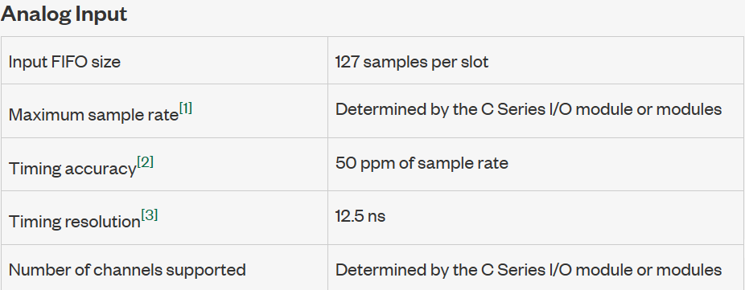  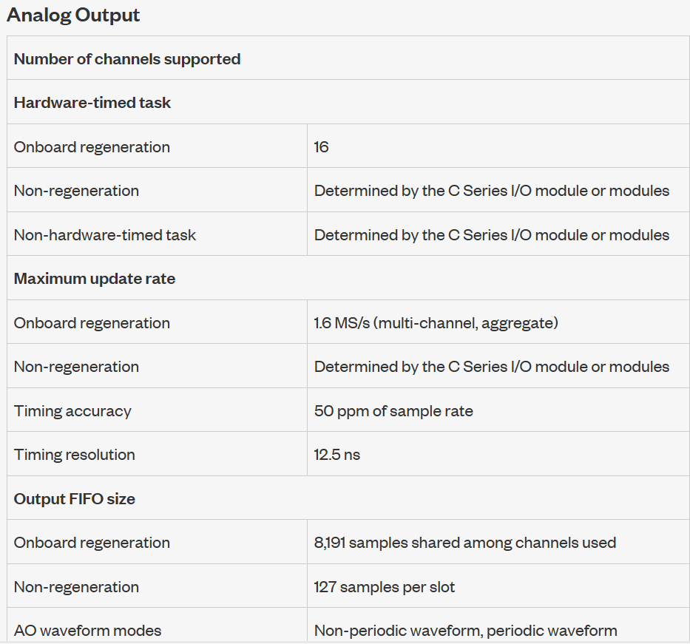  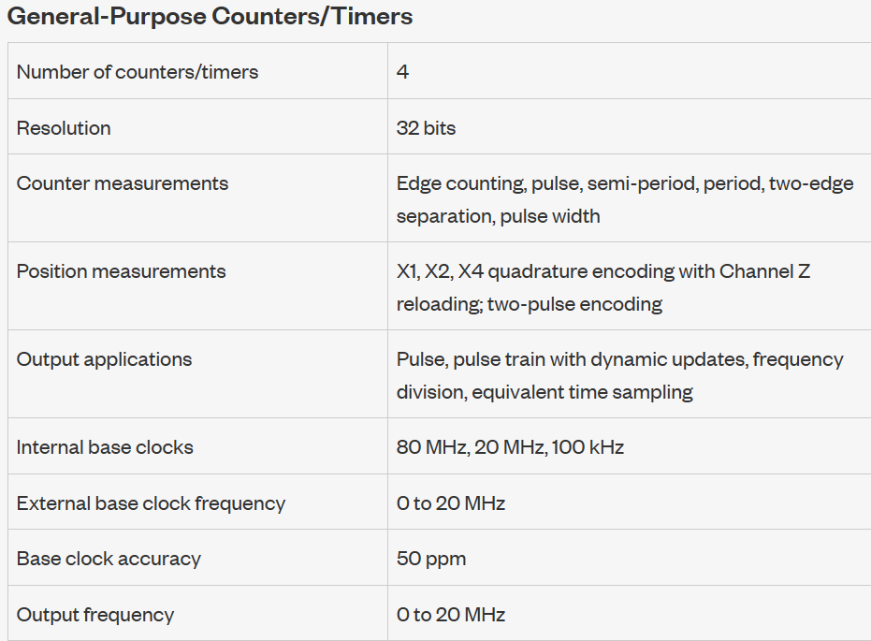 | 1 set
Wind Speed Sensor / Anemometer | Rated Supply voltage (VDC): 12 – 24  Power consumption Voltage MAX ≤ 0.3W  Output signal range (mA) 4 to 20  Resolution (m/s) 0.1  Effective measurement range 0-30m/s  System error ±3%  Transmission distance (m)  Max Wind Speed -40 ~ +80  Working temperature (℃)  Length (mm) 180  Height (mm) 120  Weight (gm) 255  Shipment Weight 0.8 kg  Shipment Dimensions 24 × 22 × 20 cm | 1 set
Humidity Sensor | - Analog outputs 0-5, 0-10V, 4-20 mA  - Mounting plate with two-piece terminal blocks provide quick, easy wiring.  - Gas permeable, water resistant humidity sensor filter prevents particulate and water contamination of the sensor.  - Sensing Method: Fully integrated humidity and temperature  - Power Supply Requirements 18-30 VAC RMS, 50/60 Hz, or 18 to 42 VDC, polarity protected  - Power Consumption Typical 0.7 W at nominal voltage of 24V AC RMS  - RH Accuracy (25°C) ±2.5% RH (20 to 80% RH) ±3.5% RH (80% RH)  - Active Temperature Range 0 to 50°C  - Active Temperature Accuracy ±0.8°C @ 22°C  - Thermistor Type NTC 10 K W thermistor (passive)  - Operating Conditions • 32°F to 122°F (0°C to 50°C) • 0 to 95% RH, non-condensing  - Thermistor Accuracy ±1°C (15° to 35°C)  - RH Sensing Element Capacitive polymer sensor | 1 set
Thermocouple Sensor | - J Type thermocouple sensor compatible with reputed Data Acquisition Systems from NI or equivalent.  - 32°F to 900°F Temperature Sensor | 1 set
Solar Radiation Sensor + Light Sensor with power supply | Solar Radiation Sensor + Light Sensor with power supply unit output : 4-20mA/0-10V | 1 set
Halogen Light: | Minimum 2000Watt | 1 set
Pyranometer | 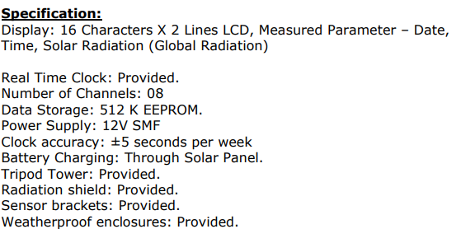  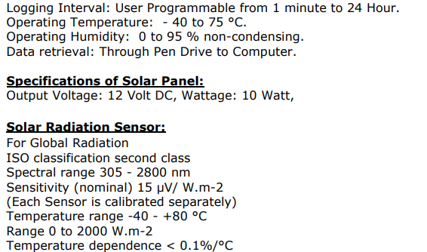 | 1 set
Signature with Date and Seal of the Bidder/Tenderer
Annexure-1

ODISHA UNIVERSITY OF TECHNOLOGY AND RESEARCH
Techno Campus, Ghatikia, P.O.MahalaxmiViharBHUBANESWAR-751029 ODISHA, INDIA, www.outr.ac.in, Email: registrar@outr.ac.in

***********************************************************************************

TECHNICAL BID

(To be enclosed in separate sealed cover)
Sl. No. | Name of the Item | Specification | Make & model | Qty. Required
 | Supply, installation, testing and commission of Chamber with Data Acquisition System | - The size of the chamber should be approx. around 10 ft.  - It should be a closed enclosure made with industry grade material.  - The chamber should have a fixture to hold Halogen Light.  - DAQ Chassis No of Slots: 4 or higher , modular & compact in nature  - Modules Required: For Voltage , Current & Temperature measurements preferably  - Basic version of Labview software should be supplied along with the Data Acquisition System.  Specifications of DAQ Chassis |  | 1 set
 | Supply, installation, testing and commission of Wind Speed Sensor / Anemometer | Rated Supply voltage (VDC): 12 – 24  Power consumption Voltage MAX ≤ 0.3W  Output signal range (mA) 4 to 20  Resolution (m/s) 0.1  Effective measurement range 0-30m/s  System error ±3%  Transmission distance (m)  Max Wind Speed -40 ~ +80  Working temperature (℃)  Length (mm) 180  Height (mm) 120  Weight (gm) 255  Shipment Weight 0.8 kg  Shipment Dimensions 24 × 22 × 20 cm |  | 1 set
 | Supply, installation, testing and commission of Humidity Sensor | - Analog outputs 0-5, 0-10V, 4-20 mA  - Mounting plate with two-piece terminal blocks provide quick, easy wiring.  - Gas permeable, water resistant humidity sensor filter prevents particulate and water contamination of the sensor.  - Sensing Method: Fully integrated humidity and temperature  - Power Supply Requirements 18-30 VAC RMS, 50/60 Hz, or 18 to 42 VDC, polarity protected  - Power Consumption Typical 0.7 W at nominal voltage of 24V AC RMS  - RH Accuracy (25°C) ±2.5% RH (20 to 80% RH) ±3.5% RH (80% RH)  - Active Temperature Range 0 to 50°C  - Active Temperature Accuracy ±0.8°C @ 22°C  - Thermistor Type NTC 10 K W thermistor (passive)  - Operating Conditions • 32°F to 122°F (0°C to 50°C) • 0 to 95% RH, non-condensing  - Thermistor Accuracy ±1°C (15° to 35°C)  - RH Sensing Element Capacitive polymer sensor |  | 1 set
 | Supply, installation, testing and commission of Thermocouple Sensor | - J Type thermocouple sensor compatible with reputed Data Acquisition Systems from NI or equivalent.  - 32°F to 900°F Temperature Sensor |  | 1 set
 | Supply, installation, testing and commission of Solar Radiation Sensor + Light Sensor with power supply | Solar Radiation Sensor + Light Sensor with power supply unit output : 4-20mA/0-10V |  | 1 set
 | Supply, installation, testing and commission of Halogen Light: | Minimum 2000Watt |  | 1 set
 | Supply, installation, testing and commission of Chamber with Data Acquisition System Pyranometer |  |  | 1 set

Note: A DD for Rs.10,000/- (EMD) and Rs.6000/- (Tender document fee) should be enclosed with this bid.

- Name of the bidder

  - Full postal address

  - Full address of the premises

  - Telephone number and Fax Number

  - E-mail id

- a) Tender Cost: Rs……………………...D.D. No………..……………date………………
b) EMD: Rs………………………D.D. No………..……………date………………

- Registration No. of Firm:
(Copy of Document showing Registration of Firm shall be enclosed)

- Tax Clearance Certificate and GSTIN No:
(Copy of Tax Clearance Certificate and GSTIN No. proof shall be enclosed)
- Income Tax Clearance Certificate:
(Copy of IT Clearance Certificate and PAN No. proof shall be enclosed)

- Total annual turn-over(value in Rupees)(Previous year):

(Copy of Balance Sheet / Audit Statement / IT returns, etc. to be attached as proof)

- Past supply details for 3 years
(Copy of proof shall be enclosed)

- Whether similar job work undertaken in the past, if so details:

Customer Quantity supplied Year

Signature with Date and Seal of the Bidder/Tenderer
Annexure-2
ODISHA UNIVERSITY OF TECHNOLOGY AND RESEARCH
Techno Campus, Ghatikia, P.O.MahalaxmiViharBHUBANESWAR-751029 ODISHA, INDIA
www.outr.ac.in Email: registrar@outr.ac.in

***********************************************************************************

FINANCIAL BID
(To be enclosed in separate sealed cover)

Sl.  No. | Item Description | Make / Model | Qty. Req. | Unit Cost withoutGST | GST  applicable | Total cost per unit  In Rs.
A | 1.Chamber with Data Acquisition System |  | 1 set
A | 2.Wind Speed Sensor / Anemometer |  | 1 set
A | 3. Humidity Sensor |  | 1 set
A | 4.Thermocouple Sensor |  | 1 set
A | 5. Solar Radiation Sensor + Light Sensor with power supply unit output : 4-20mA/0-10V |  | 1 set
A | 6.Halogen Light: Minimum 2000Watt |  | 1 set
 | Total amount (Item 1 to 6)

B | 7.Pyranometer |  | 1 set

Proforma for submitting Undertaking on Acceptance of Tender requirement
To
The Registrar,
Odisha University of Technology and Research

Bhubaneswar-751029

Sub: Submission of Tender for Supply, installation, testing and commission of 1.Chamber with Data Acquisition System 2.Wind Speed Sensor / Anemometer 3. Humidity Sensor 4.Thermocouple Sensor 5. Solar Radiation Sensor + Light Sensor with power supply unit output : 4-20mA/0-10V 6.Halogen Light: Minimum 2000Watt 7.Pyranometer for OUTR

Sir / Madam,

Having examined the conditions of contract and specifications including addenda, I/we, the undersigned, offer to undertake supply, installation, testing and commission of 1.Chamber with Data Acquisition System 2.Wind Speed Sensor / Anemometer 3. Humidity Sensor 4.Thermocouple Sensor 5. Solar Radiation Sensor + Light Sensor with power supply unit output : 4-20mA/0-10V 6.Halogen Light: Minimum 2000Watt 7.Pyranometer for OUTR
Bhubaneswar, in conformity with the specifications, terms & conditions of bid.

- I/We agree to abide by the terms and provisions of the said conditions of the contract and provisions contained in the notice inviting tender. I/We hereby unconditionally accept(s) the bid conditions.

It is certified that I/we have not stipulated any condition(s) in our bid offer. In case any condition(s) are found in our bid offer violated after opening bid, I/We agree that the bid shall be rejected without prejudice to any other right or remedy be at liberty to forfeit the EMD absolutely.

- I/We hereby submit the earnest money of [INR…………..……….……] for the bid for the above mentioned work in the form of demand draft.

- That, I/We declare that I/We have not paid and shall not pay any bribe to any officer of OUTR for awarding this contract at any stage during its execution or at the time of payment of bills, and further if any officer of OUTR asks for bribe/gratification, I/We shall immediately report it to the OUTR authorities.

- That, I/We undertake that OUTR’s tender document shall form part of contract agreement.

I/We understand that you are not bound to accept the lowest or any bid, you shall receive.

Thanking you

Yours faithfully

Dated:

Signature of Bidder

Name: ……………………

Telephone:……………….
Witness…...................

Signature....................
Address......................

