
ODISHA UNIVERSITY OF TECHNOLOGY AND RESEARCH
Techno Campus, Ghatikia, P.O.-Mahalaxmi Vihar
BHUBANESWAR-751029, ODISHA

Tender Notice No. OUTR/Convocation/Dress/2024-25/24 Date : 20/01/2025
NOTICE INVITNG TENDER
Sealed tenders are invited under two bid systems from reputed Registered Firms/Agencies/Suppliers for Supply of Dresses (Kurta, Jacket and Uttariya) for 2nd Convocation of OUTR, Bhubaneswar”. The sealed tender will be received by Speed post/ Registered post/ Courier only. No hand delivery will be accepted. The authority will not be held responsible for any postal delay. Tender received after the scheduled date and time will not be accepted. The date of opening of tender is mentioned in the respective tender document, which will be opened in the office of the PIC, Purchase, Odisha University of Technology and Research, Bhubaneswar in the presence of bidders and/or their nominees if they so wish. The last date of tender submission is 04.02.2025 at 3:00 P.M. The tender bid documents with details of terms and conditions are to be downloaded from the University website: www.outr.ac.in .
The authority reserves the right to reject/ cancel the tenders in whole or in part without assigning any reason thereof.
IMPORTANT: Prospective bidders are advised to regularly visit the University website for any Updates/Corrigendum/Amendment. Any subsequent updates will be announced on the University website only.

REGISTRAR

Tender Notice No.: OUTR/Convocation/Dress/2024-25/24 Date : 20.01.2025

NOTICE INVITING TENDER

FOR SUPPLY OF DRESSES (Kurta, Jacket and Uttariya) FOR
2nd CONVOCATION
OF O.U.T.R., BHUBANESWAR


ODISHA UNIVERSITY OF TECHNOLOGY AND RESEARCH
Techno Campus, P.O.: Mahalaxmivihar,
BHUBANESWAR -751029, INDIA

NOTICE INVITNG TENDER
The Registrar, Odisha University of Technology and Research (OUTR), Bhubaneswar invites sealed tenders from reputed Registered Firms/Agencies/Suppliers for Supply of Dresses (Kurta, Jacket and Uttariya) for 2nd Convocation of OUTR, Bhubaneswar”. Interested eligible Bidders may obtain detail information and list of items with technical specifications from the website of the University www.outr.ac.in
Critical Information
Submission of a proposal in response to this notice shall be deemed to have been done after careful study and examination of this document with full understanding of its terms, conditions and implications.
Sl. No. | Information | Details
1 | Tender Number and Date | OUTR/Convocation/Dress/2024-25/24 Date : 20.01.2025
2 | Period during which tender document will be available on website www.outr.ac.in | 20/01/2025 to 04.02.2025 upto 3.00 p.m.
3 | Tender Fee( Non- Refundable) | Rs. 1,000/- (Rupees One thousand only) by Demand Draft to be drawn in favour of " (Odisha University of Technology and Research Bhubaneswar drawn on any Scheduled Bank payable at Bhubaneswar)"
4 | Bid security (EMD) : (refundable but Non-interest bearing) ; EMD Amount (Will be accepted only through D.D/Pay Order/Banker’s Cheque. The bid security is exempted to the MSE bidders only. However, proper and valid documents in this regard must be submitted by the bidders in support of their claim. | Rs. 26,000/-(Rupees Twenty Six thousand only) by Demand Draft to be drawn in favour of “(Odisha University of Technology and Research Bhubaneswar drawn on any Scheduled Bank payable at Bhubaneswar)”
5 | Type of Bid | Two Bid ; Cover I - Technical Bid  Cover II - Price Bid as per the format
6 | Last date & time for submission of tender | 04.02.2025 upto 3.00 p.m.
7 | Date & time of opening of Technical Bid | 05.02.2025 at 3.00 p.m.
8 | Date & time of opening of Financial Bid | To be intimated later to Technical qualified bidders
9 | Pre bid meeting | 24.01.2025 at 11.30 a.m. in the Office of the PIC, Purchase
10 | Delivery | 30 Days from the date of Purchase Order
11 | Place of opening of Technical Bid & Financial Bid | Office of the PIC, Purchase, OUTR, Bhubaneswar
12 | For any query please contact | Prof. Ullash Ku. Rout, Ph. No. 7978360990, E-mail : ukrout@outr.ac.in
13 | Tender Should be addressed to | The Registrar,  Odisha University of Technology and Research, Techno campus, Mahalaxmi Vihar, Bhubaneswar, PIN- 751 029

REGISTRAR

CONTENTS OF TENDER DOCUMENTS

Sl. No. | Description of contents | Page No
1 | Eligibility Criteria | 5
2 | Instructions to bidders | 5-08
3 | General Terms and Conditions | 08-11
4 | Scope of Supply and Specification | 12-14
5 | Acceptance of Terms and conditions of Tender (Annexure-I) | 15
6 | Particulars about Tenderer (Annexure-II ) | 16
7 | Compliance to Restriction on Countries sharing Land border with India. (Annexure-III) | 17
8 | Bidder’s Authorisation Form (Annexure-IV) | 18
9 | BOQ (Annexure-V) | 19
10 | Bid Security Declaration form (Annexure-VI) | 20
11 | Criminal Liability Form (Annexure-VII) | 21
12 | Check List for Tenderer (Annexure-VIII) | 22

1. Eligibility of bidders :

1.1 Eligibility:
Those who fulfill the following criteria are eligible to participate in the tender.
- The Bidder should be a body corporate incorporated in India under the Companies Act, 1956 or 2013 Or Partnership firm, registered under Partnership Act 1932 Or Registered Proprietorship. The Bidder shall be registered legal entity under relevant act and a copy of each of registrations shall be attached with the bids.

- Minimum Three (3) years experience having successfully completed at least 3 works of making dresses of this nature in National Importance Institutions /Central/State govt. organization/PSUs/MNCs/Private universities for a minimum value of Rs. 5,00,000/- (Rupees Five Lakh only) each during the last 3 financial year.
- Registration Certificate/Certificate of incorporation, if any, including the certificate of MSME/NSIC/Other for EMD Exemption.
- Minimum Average Annual Turn Over of the bidder of last 3 financial years should amount to Rs. 30 lakhs. (The bidder should submit Audited Financial Statement for last 3 years to this effect, 2021-22,2022-23, 2023-24)
- Bidder should have valid GST registration certificate with upto date return.
- Bidder should have Permanent Account Number (PAN); and Income Tax Return for last three financial year ending on 31st March 2024.
- Copy of Audited Balance sheet, Profit & Loss Statement for last three financial year ending on 31st March 2024 duly signed by a Chartered accountant.
- Bidder should not have been black listed / Debarred by any Government Department, Organization, Agency, Authority or any Public Sector Undertaking owned by the Government during the last three years as on the date for Bid submission
- The bidder must provide evidence of successful execution of supply orders in reputed organizations. Similar Purchase Order copies executed in National Importance Institutions like, IITs, NITs, IISERs, NISER, Central Universities, State Universities/PSUs/MNCs/Private Universities etc.
- Instructions to Bidders :
2. TENDER COST & EARNEST MONEY DEPOSIT (EMD) / BID SECURITY
  - Tender Cost (non-refundable) of Rs. 1,000/- (Rupees One thousand only) and EMD / Bid Security (refundable) of Rs. 26,000/-(Rupees Twenty Six thousand only)) in the form of Demand Draft (DD) in favour of “Odisha University of Technology and Research” payable at Bhubaneswar drawn on any scheduled commercial bank except Co-operative Bank and Gramin Bank.
  - EMD / Bid Security of unsuccessful bidder will be returned to them without any interest at the earliest and latest on or before the 30 days after the award of contract to successful bidder.
  - Bidder registered with Ministry of MSME as per public procurement policy for Micro & Small Enterprises (MSE) are exempted categories from payment of EMD provided that the registration certificates issued by agencies must be valid and with relevant purpose as on closing date of tender. The bidder has to submit the Bid Security Form as per the Annexure.
  - Any bid without accompanying with EMD and Tender Cost is liable to be treated as non-responsive and rejected.
  - The EMD / Bid Security of the bidder who withdraws its bid in breach of terms and conditions of contracts, withdraws at any stage after opening of technical bid and who evades or refuses to accept the Award of Contract after being L1 with the period of validity, shall be liable to forfeiture.
- 3. Submission of Bidding Documents :
The tender is to be submitted in two separate sealed Envelopes and further sealed in one Envelope mentioning thereon the Envelope No.1 and Envelope No. 2 and contents as indicated below:
3.1. Envelope Number-1 (Technical Bid)
Cover forming Envelope -1 of the Tender shall be super scribed with words Technical Bid of “Tender for ____________________________ ” along with tender number and due date.
Envelope number-1 shall contain the DD for EMD & Tender document fees, Qualification documents along with the tender document duly filled up and signed by the Bidding Firm on each page after affixing rubber stamp of the Firm/Agency, Qualification documents :
Such as :

> Bid Securing Declaration Form for EMD exemption as per the Annexure
> Copies of Income Tax return (last three financial year and copy of PAN )
> Firm Registration
> GST Registration certificate
> Similar Purchase Order copies executed in National Importance Institutions like, IITs, NITs, IISERs, NISER, Central/State Universities/PSUs/MNCs/Private Universities etc.
> Annual average turn over of last 3 financial years (2021-22, 2022-23, 2023-24).
> Criminal Liability Form
> Bidder’s Authorisation form
> All other documents as per attached Annexures Except Price BoQ)

3.2 Envelope Number-2 (Financial Bid)
Sealed cover forming Envelope -2 of the Tender shall contain Financial Bid in the prescribed Proforma which should be super scribed with words Financial Bid of “Tender for ____________________ ” along with tender number and due date.
3.3 Both the Sealed covers containing Envelope -1 and Envelope -2, shall be put in another third Envelope and sealed properly super scribing the words “Tender for _____________________________ ” along with tender number, date and due date addressed to the Registrar, Odisha University of Technology and Research, Techno-Campus, Ghatikia, Mahalaxmi Vihar, Bhubaneswar-751029 on or before the date & time mentioned in Tender. Any tender received after the prescribed date & time will not accept.
- AMENDMENT TO BID DOCUMENTS :
At any time prior to the date of submission of bid, OUTR may, for any reason, either of its own or in response to a clarification from a prospective bidder, modify the bidding documents by an amendment / corrigendum. Any such amendment / corrigendum will be duly notified through the University’s website only. Prospective bidders are advised to check the website every now and then for any amendment / corrigendum.

- The bidder is expected to have examined all instructions, forms, terms and specification in the Bid Document. Failure to furnish the bid not substantially responsive to the Bid document in every respect will be at the bidders risk and may result in rejection of the Bid.

- Validity of Tender : The prospective bidders should keep their offers valid up to 120 days from the date of tender opening.

- Pre Bid Meeting : A pre bid meeting will be held on 24.01.2025 at 11.30 A.M. in the office of the PIC, Purchase, OUTR, Bhubaneswar. The interested bidders are requested to bring the samples for any clarification in this regard.

- Clarification of Bids : In case any bidder requires any clarification, bidder can feel free to raise their query before the last date of submission of tender document.

- BID PRICES :

9.1 The bidder shall give FOR destination price, inclusive of all Taxes for supply of dresses (Kurta, Jacket and Uttariya), Packing, with replacement of dresses in case of any defect found on the dresses for convocation of OUTR. The price should be indicated as per BOQ/Price Schedule as per the Format under Financial Cover.
9.2 The price quoted by the bidder shall remain fixed during the entire period of contract and shall not be subject to variation on any account.

10. GUARANTEE/WARRANTY:
The supplier will replace the dresses in case of any defect found on the dresses without any extra charges.

11.ADVANCE PAYMENT: OUTR, Bhubaneswar, will not pay any advance payment(s) against supply material or against Proforma invoice to vendor.
- Late and delayed tender : Late and delayed tender will not be considered. In case any unscheduled holiday occurs on the prescribed opening date, the next working day shall be the prescribed date of opening.
- Reasonableness of Rates Received : Procuring Entity shall evaluate whether the rates received in the Bids are reasonable. If the rates received are considered abnormally low or unreasonably high, it reserves its right to reject any or all Bids; abandon/ cancel the Tender process and issue another tender for the identical or similar Goods.
- Price Negotiation : Usually, there shall be no price negotiations. However, the Procuring Entity reserves its right to negotiate with the bidder securing the highest evaluated scores ranked H1, who is techno-commercially suitable for supplying bulk quantity and on whom the contract would have been placed but for the decision to negotiate.
- Right to Vary Quantities at the Time of Award : At the time of contract award, the Procuring Entity reserves the right to increase or decrease, without any change in the unit prices or other terms and conditions of the bid provided that increase/ decrease does not exceed 25 (twenty-five) percent of tendered quantity.
- Payments :
100% Payment through bank transfer (RTGS) will be made after successful supply of dresses to OUTR Bhubaneswar and submission of Tax invoice in triplicate.
17. Liquidated Damage : The Liquidated Damages shall be levied, for delay in supply beyond the contractual delivery date at the rate 1% per month or part thereof on delayed supply of goods and/or services until actual delivery or performance subject to a maximum of 10% of the value of delayed stores.
18. Bidders compliance to restrictions on Country sharing land border with India
Any bidder from a country which shares a land border with India will be eligible to bid in this tender only if the bidder is registered with Competent Authority/ Department for Promotion of Industry and Internal Trade (DPIIT) as per extant GOI rules.
19. The pre qualified bidders have to give the demonstration of their products before the TEC for Technical evaluation on the date fixed by the committee. The date and time will be intimated to pre qualified bidders by phone/e-mail.

D. GENERAL TERMS AND CONDITIONS:
20. BID EVALUATION PROCEDURES
- Technical bids will be opened on the specified date & time by Tender Evaluation Committee duly constituted by the competent authority of OUTR Bhubaneswar in the presence of bidder or of his representative who wish to attend.
- They must bring proper authorisation from their firm/agency at the time of opening of the bids failing which they will not be allowed to participate in the opening process. Short listing will be done on the basis of eligibility criteria mentioned in the tender.
21. CLARIFICATION ON TECHNICAL BID EVALUATION

- Technical bids shall be evaluated based on the available documents submitted by the bidder and the methodology adopted by the committee. To assist in the examination, evaluation and comparison of the bids, and qualification of bidders, the committee may, at its discretion ask any bidder for a clarification of its bid.
- If a bidder does not provide clarification on its bid asked for in the University’s request for clarification, the bid may be treated as not valid and liable for rejection.
- University also reserves the right to seek confirmation / clarification from the issuing agency for the supporting documents submitted by the bidder.
- The technical bid shall be evaluated on the basis of following parameters/criteria :
- The bid shall be evaluated on – Quality-cum-Cost Base Selection (QCBS) method.
22. Technical Evaluation Criteria
The bidders qualifying the initial criteria of basic eligibility will be evaluated for following criteria by scoring method on the basis of details furnished by them for technical bid qualification:
Sl. No. | Evaluation Parameter | Total Marks | Criteria for award of Marks
1 | No. of Years of Work Experience. Work order copy of clients should be enclosed for this. | 20 | 3 Years to 5 years : 10 marks  > 5 Years to 8 years : 15 marks  > 8 years : 20 marks
2 | The Vendor must have successfully completed at least 3 works of making dresses of this nature in National Importance Institutions /Central/State govt. organization/ PSUs/MNCs/Private for a minimum value of Rs. 5 Lakhs each, in last 3 financial years (2021-22, 2022-23, 2023-24) | 15 | 3 Clients to 5 clients : 05 marks  > 5 Clients to 7 Clients : 10 marks  > 7 Clients : 15 marks
3 | The average annual turnover of the Company for the financial years of 2021-22, 2022-23, 2023-24. | 15 | > 30 lakhs to 50 lakhs : 5 marks  > 50 lakhs to 70 lakhs : 10 marks  > 70 lakhs : 15 marks
4 | Category of University, to which Dresses (Kurta, Jacket and Uttariya) are supplied | 20 | Private : 10 marks  Private and/or State Govt. : 15 marks  Private and/or State Govt or Central Govt. : 20 marks
5 | Marks to be assigned by TEC considering the a) Aesthetic b) Quality of Materials / Quality of Finished Dresses. | 30 | Good : 10 marks  Very Good : 20 marks  Excellent : 30 marks

Note:
  - Technical Bid Evaluation will be done on the scale of 100 Marks/points. The bidders qualifying Technical stage with 60 marks/points or more will be considered as technically responsive bid and shall be considered for the opening of financial bid.
  - The Technical Bid Criteria mentioned in table must be fulfilled and supported by relevant document as indicated in the table above.
  - Technical bid evaluation will be done by a Technical Evaluation Committee (TEC) constituted by the competent authority of OUTR.TEC will go through all the documents submitted by the bidder to do the technical evaluation. TEC will also be free to do reference checks with the client(s) of the bidder as per the details provided by the bidder. In addition, TEC may seek clarifications from the bidder. The decision of TEC will be final.

23. FINANCIAL BID PROCEDURE & EVALUATION

a. Financial bid of those technically qualified bidders (based on technical proposal and technical evaluation as indicated above) will only be opened by the authorised person on the specified date and time or to be intimated well in advance in the presence of the bidders or his authorised representative who wish to attend.
b. Tender for this contract will be assessed in accordance with Quality-cum-Cost Base Selection (QCBS) method.
24. Quality and Cost Based Selection (QCBS): This method will be followed during the overall selection process with 70 % weightage to technical score and 30 % weightage to financial score. The bidders securing the highest evaluated scores will be ranked H1 and thereafter others will be ranked in the order of H2, H3 and so on.

Computation of Final Evaluated Score using Technical Score and Financial Score

Technical Score of the Bidder (TSB) is the score awarded to the bidder by the Technical Evaluation Committee of the University as per the Technical Evaluation Table.

Financial Score of the Bidder (FSB) is obtained using the price of the concerned bidder and that of the lowest bidder (without taxes). This is computed by the evaluation committee as per the following formula:

FSB = (Bid amount of the lowest bidder / Bid amount of the concerned bidder) x 100

The Final Evaluated Score (FES) of the bidder is based on both the technical evaluation score and financial bid score. The technical evaluation gets 70% weightage and financial bid gets 30% weightage in the final score. The TEC will evaluate and compare the bids that have been determined to be substantially responsive using the following formula:

FES = [0.70 x TSB + 0.30 x FSB]

Where FES: Final Evaluated Score; TSB: Technical Score of the Bidder; FSB: Financial Score of the concerned Bidder.
In case of a tie on FES, bidder of higher Technical Score will be eligible for the award of contract.

25. AWARD OF CONTRACT :

- OUTR Bhubaneswar shall award the contract to the Bidder(s) whose Bid has been determined to be substantively responsive, eligible and qualified, technically suitable and whose Final Evaluated Score (FES) stands highest as per evaluation criteria.

- The authority reserves the right to accept or reject any bid including the highest Final Evaluated Score bidder and to cancel the bidding process and reject all bids, at any time prior to award of contract, without assigning to any reason thereof or any obligations to inform the affected bidder or bidders of the grounds for the said action.
- Delivery :

- Delivery 30 Days from the date of Purchase Order.
- Safe Delivery: All aspects of safe delivery shall be the exclusive responsibility of the vendor.
- INDEMNITY : The successful bidder shall indemnify and hold the university harmless from and against all claims, damages, losses and expenses arising out of or resulting from the purchase under the contract provided by the supplier.

- Force Majeure:
1. For purposes of this Clause, “Force Majeure” means an event or situation beyond the control of the Supplier that is not foreseeable, is unavoidable, and its origin is not due to negligence or lack of care on the part of the Supplier. Such events may include, but not be limited to, acts of the Purchaser in its sovereign capacity, wars or revolutions, fires, floods, epidemics, quarantine restrictions, and freight embargoes.
2. If a Force Majeure situation arises, the Supplier shall promptly notify the Purchaser in writing of such conditions and the cause thereof within 15 days of its occurrence. Unless otherwise directed by the Purchaser in writing, the Supplier shall continue to perform its obligations under the Contract as far as is reasonably practical, and shall seek all reasonable alternative means for performance not prevented by the Force Majeure event.
3. If the performance in whole or in part or any obligations under the contract is prevented or delayed by any reason of Force Majeure for a period exceeding 60 days, either party may at its option terminate the contract without any financial repercussion on either side.

- Applicable Law:
- The contract shall be governed by the laws and procedures established by Govt. of India/Govt. of Odisha within the framework of applicable legislation and enactment made from time to time concerning such Commercial dealings/processing and subject to exclusive jurisdiction of Competent Court and Forum in Bhubaneswar only.
(b) Any dispute arising out of this purchase shall be referred to the decision of Vice Chancellor, OUTR. The decision of Vice Chancellor shall be final and binding.

F. SCOPE OF SUPPLY AND SPECIFICATIONS:
Supply of Dresses (Kurta, Jacket and Uttariya) for 2nd Convocation of OUTR, Bhubaneswar.
- Kurta – 1125 Numbers of various sizes as per requirement.
- Jacket – 43 Nos.
- Uttariya – 1168 Nos.
- Handloom
- 100% Genuine
- Fabric 100 % cotton
- Count 80x80 or more
- ikkat pattern
- Free Style of Stitching
- Decent and attractive Colour (7 Colours)
- Decent finishing
- Item wise packing
Other Services
- Free Shipping
- 10 Days Replacement Guarantee
- Best Product Price
NOTE: 1) FINAL DESIGN AND COLOUR WILL BE DECIDED BY TECHNICAL EVALUATION COMMITTEE.
2) The quantity mentioned above are indicative, may vary at the time of placement of order.

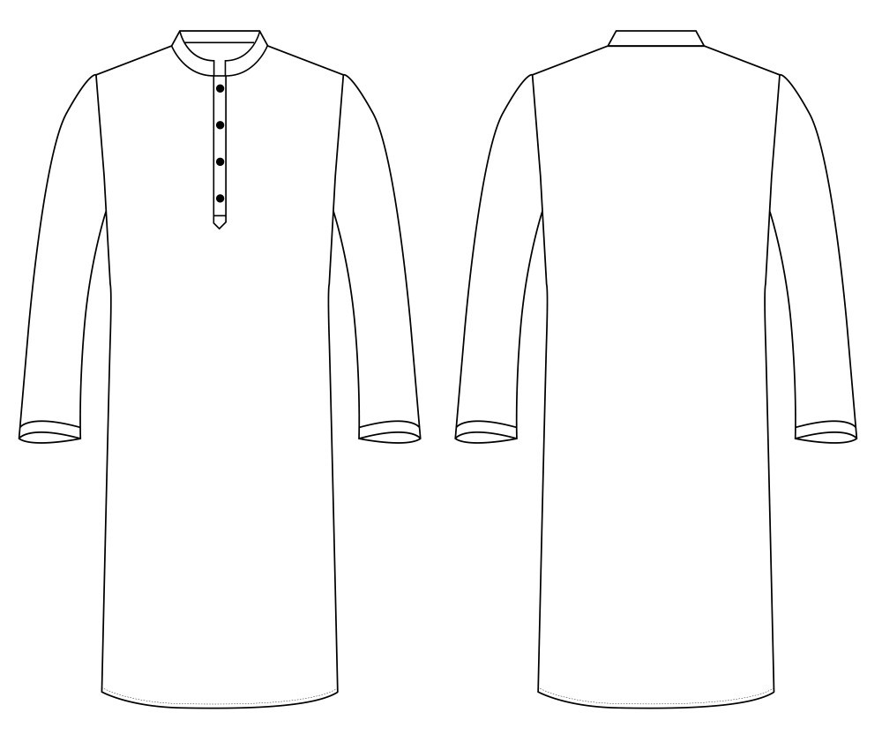

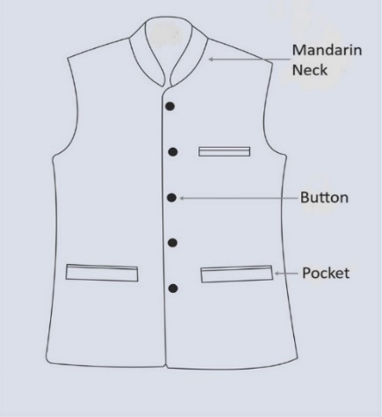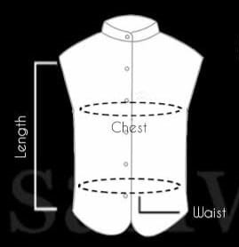

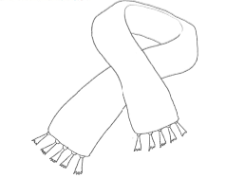

UTTARIYA SIZE: 70 INCH X 20 INCH

SPECIFICATION OF VARIOUS SIZES
KURTA (TOP) SIZE CHART

Lable Size | Chest  (in inches) | Waist  (in inches) | Sleeve length (in inches) | Shoulder width (in inches) | Length  (in inches)
Small | 36 | 37 | 25 | 18 | 41
Medium | 38 | 39 | 25.5 | 18.5 | 41
Large | 40 | 41 | 26 | 19 | 42
X-Large | 42 | 43.5 | 26 | 19.5 | 42
XX-Large | 44 | 44.5 | 26 | 20 | 43

JACKET MEASURMENT CHART IN INCH
Description | S/36 | M/38 | L/40 | XL/42 | 2XL/44 | 3XL/46
CHEST | 39 | 41 | 43 | 45 | 47 | 49
WAIST | 39 | 41 | 43 | 45 | 47 | 49
LENGTH | 25.5 | 26.5 | 27.5 | 28.5 | 29.5 | 30.5

ANNEXURE – I

LETTER OF UNDERTAKING AND ACCEPTANCE OF TERMS & CONDITIONS OF BID
To
The Registrar,
Odisha University of Technology & Research,
Ghatikia, P.O.: Mahalaxmi Vihar,
Bhubaneswar-751 029

Ref : Invitation of Tender Notice No. Dated.

I/We, the undersigned declare that :
1. I/ We have downloaded / obtained the Bid document(s) for the above mentioned ‘Bid’ from the web site(s) namely: …………as per your advertisement, given in the above mentioned website(s).
2. I/ We hereby certify that I / we have read the entire terms and conditions of the Bid documents from Page No. _______ to ______ (including all documents like annexure(s) etc.), which form part of the contract agreement and I / we shall abide hereby by the terms / conditions / clauses contained therein.
3. The corrigendum(s) issued from time to time by your university too have also been taken into consideration, while submitting this acceptance letter.
4. I/We are ready to execute the contract in conformity with the tender document, in case we are found successful as a tenderer.
5. Our bid shall be valid for a period of _____ days from the date of Opening of price bid and shall not revoke the same.
6. If our bid is accepted, I/We undertake to comply all other formalities as per the tender document and purchase order.
7. I/we also declare that neither our firm/company/Proprietorship concerned was blacklisted in past nor any of our office bearer was convicted in any court of law.
8. The detailed particulars of the tenderer is mentioned and attached separately.
9. I / We certify that all information furnished by the our Firm is true & correct and in the event that the information is found to be incorrect/untrue or found violated, then your university shall without giving any notice or reason therefore or summarily reject the bid or terminate the contract, without prejudice to any other rights or remedy including the forfeiture of the full said earnest money deposit absolutely.

Yours sincerely,

Authorized signatory of the Bidder
(Authorised person shall attach a copy of the authorization for signing on behalf of the Bidding Company)
Full name and designation
With seal

ANNEXURE – II
(PRE-QUALIFICATION/ELIGIBILITY)

PARTICULARS OF THE BIDDERS TO BE FURNISHED IN TECHNICAL BID FOR THE PURPOSE OF PRE-QUALIFICATION:
1. | Name of Organization/Firm/Company
2. | Address & Telephone Number  (Furnish address proof)
3. | Year of establishment must be in similar business for minimum 03 years from the date of submission of BID.
4. | Status of the Firm  (Company/Firm/Proprietary)  Supporting document to be enclosed.
5. | Name & Mobile Number of Directors/Partners/Proprietor
6. | Registration with GST., mention number & date. Furnish also copies of GST registration certificate alongwith uptodate return.
7. | Permanent Account Number (PAN) Furnish copy of PAN alongwith return of preceding three years.
8. | Average Annual turnover of the company in last 3 financial year (2021-22, 2022-23,2023-24). Furnish copies of audited balance sheet & profit & loss account for the last three years Certified Auditor.
9. | Must have supplied dressed of this nature in Central/State govt. organization/ PSUs/MNCs/Private Univ. and proof of such supplies should be produced
10. | Whether firm is MSEs Unit: YES/ NO  (Please Submit the Documentary Evidence for UAM and ownership details.)
11. | Bidder should be qualifying under all Land border rule of Central government
12. | Detail of Bank A/c. : Name of the A/C Holder
 | A/C Number
 | Name of the Bank and Branch
 | IFS Code

Place:
Date: Name, Signature & Seal of Bidder

ANNEXURE – III

MODEL FORMAT CERTIFICATE FOR COMPLIANCE TO RESTRICTIONS ON COUNTRIES SHARING LAND BORDER WITH INDIA

[The Bidder shall fill and provide the certificate for compliance to restrictions on countries sharing land border with India in accordance with the instructions indicated below. No alterations to its format shall be permitted and no substitutions shall be accepted. This should be done of the letter head of the firm]

Date: [insert date (as day, month and year) of Bid Submission]
Tender No.: [insert number from Invitation for Bids]
To
[insert complete name and address of Purchaser]

“We [insert complete name of Bidder] have read the clause regarding restrictions on procurement from a bidder of a country which shares a land border with India;

We [Insert complete name of Bidder] certify that we are not from such a country or; if from such a country, has been registered with the Competent Authority/ Department for Promotion of Industry and Internal Trade(DPIIT). We [Insert complete name of Bidder] hereby certify that we fulfil all requirements in this regard and is eligible to be considered.

[ Wherever applicable, evidence of valid registration by the Competent Authority shall be attached.]”

Signature of Bidder (with date and seal) ________________
Name __________________________
(Business Address with e-mail and Contact No.)

ANNEXURE – IV

(To be given on the bidder’s letter head)
Bidder’s Authorisation Certificate
To
The Registrar,
Odisha University of Technology and Research
Techno-Campus, MahalaxmiVihar
Bhubaneswar-751029
Sub : Bidder’s Authorisation Certificate
Sir,
With reference to the Tender Notice No.___________________Ms./Mr.___________________ <Name>,<Designation>, is hereby authorized to attend meetings & submit pre-qualification, technical & commercial information as may be required by you in the course of processing the above said Bid. Her/his contact mobile number is _______________ and Email id is__________________. For the purpose of validation, his/ her verified signature is as under.
Thanking you,
The specimen signature is attested below:
Name:
_________________________________
(Specimen Signature of Representative)

_________________________________
Signature of Authorizing Authority

Name of Authorizing Authority
Designation: Company Seal:

ANNEXURE –V

ODISHA UNIVERSITY OF TECHNOLOGY AND RESEARCH
Techno Campus, Ghatikia, P.O.-Mahalaxmi Vihar
BHUBANESWAR-751029, ODISHA

BILL OF QUANTITY/FINANCIAL BID
To
The Registrar,
Odisha University of Technology and Research
Techno-Campus, MahalaxmiVihar
Bhubaneswar-751029

Reg. - Tender for “ to OUTR”, – Financial Bid
Sir,
This has reference to your tender for “Supply of ________________ to OUTR”, followed by my technical bid. I have read all the terms and the conditions as stipulated in the technical and financial bid.
I offer my rate in INR as under:

Sl.  No. | Item Description | Unit | “A” Qty | “B”  Unit Price | “C”  Unit price GST % | “D =B+C”  Unit Amount with GST | “E= D X A”  Total Unit Amount with GST
1 | Kurta | No | 1125
2 | Jacket | No | 43
3 | Uttariya | No | 1168
 | TOTAL OF THE ABOVE
 | TOTAL AMOUNT IN WORDS :

Signature:
For and on behalf of the Bidder
Name :
Seal: Date: Place :

ANNEXURE – VI
BID SECURITY SELF DECLARATION FORM
Date: ___________________
Bid No. _________________
To (insert complete name and address of the purchaser)
I/We. The undersigned, declare that:
I/We understand that, according to your conditions, bids must be supported by a Bid Security Declaration.
I/We accept that I/We may be disqualified from bidding for any contract with Odisha University of Technology and Research, Bhubaneswar for a period of Two years from the date of notification if I am /We are in a breach of any obligation under the bid conditions, because I/We
- have withdrawn/modified/amended, impairs or derogates from the tender, my/our Bid during the period of bid validity specified in the form of Bid; or

- having been notified of the acceptance of our Bid by the purchaser during the period of bid validity (i) fail or reuse to execute the contract, if required, or (ii) fail or refuse to furnish the Performance Security, in accordance with the Instructions to Bidders.

I/We understand this Bid Securing Declaration shall cease to be valid if I am/we are not the successful Bidder, upon the earlier of (i) the receipt of your notification of the name of the successful Bidder; or (ii) thirty days after the expiration of the validity of my/our Bid.

Signed: (insert signature of person whose name and capacity are shown) in the capacity of (insert legal capacity of person signing the Bid Securing Declaration).

Name: (insert complete name of person signing he Bid Securing Declaration)
Duly authorized to sign the bid for an on behalf of : (insert complete name of Bidder)

Dated on _____________ day of ___________________(insert date of signing)

Corporate Seal (where appropriate)

(Note: In case of a Joint Venture, the Bid Securing Declaration must be in the name of all
partners to the Joint Venture that submits the bid)

ANNEXURE - VII

CRIMINAL LIABILITY UNDERTAKING
(To be given on Company Letter Head)

Date:_________________
To
The Registrar,
Odisha University of Technology & Research,
Ghatikia, P.O.: Mahalaxmi Vihar,
Bhubaneswar-751 029

The bidder has to furnish a certificate as per the format specified below along with the bid for not committed any offence.

I …………….…………………………………………………… aged about ………….. S/o…………………………………..Proprietor/ Partner/ Director of M/s.__________________________________________ At:______________ Po: _______________________, P.S:________________, Dist:____________________ do solemnly pledge and affirm that I/my firm/company have not committed any offence.
- Under the Prevention of Corruption Act 1988; or

- The Indian Penal Code or any other law for the time being in force, for causing any loss of life or property or causing a threat to public health as part of execution of a public procurement contract.
- That neither any criminal case nor any vigilance case is pending against me/my firm/company before any forum.
- I/my firm/company have not been blacklisted/debarred by any Central/State Government Organisation/Bodies for the last 3 years.

Signature with Designation

ANNEXURE-VIII
CHECKLIST FOR THE TENDERER
Supportive Documents must be enclosed for fulfilling Eligibility criteria, to be submitted by the Tenderer
Sl. No. | Particulars | Yes/No | Page No.
1 | Registration Certificate/Certificate of incorporation, if any
2 | Bid Security (EMD) in shape of DD or Bid Security Self Declaration Form for bid exemption of MSE bidder
3 | Tender Cost in shape of DD
4 | Acceptance of Terms and conditions of Tender
5 | Have you attached the proof of authorization to sign on behalf of the Bidder?
6 | Average Annual Turnover of at least 30 lakhs INR during last 3 financial years i.e. 2021-22, 2022-23 and 2023-24.
7 | Registered with GST. Furnish the copy of GST registration certificate and upto date return.
8 | Permanent Account Number (PAN) Furnish copy of PAN, Copy of IT Return Acknowledgement for the preceding three financial years
9 | Have you submitted the Price Bid (BOQ) as per the prescribed format in the separate cover ? |  | NA
10 | Must have supplied dresses of this nature in National Importance institutions/Central/State govt. organization/ PSUs/MNCs/Private Univ. and proof of such supplies should be produced with 3 years experience with minimum value of Rs. 5,00,000/- each
11 | Certificate of Land Border Sharing as per tender annexure
12 | Criminal liability Form
13 | Any Other

Place :
Date :

