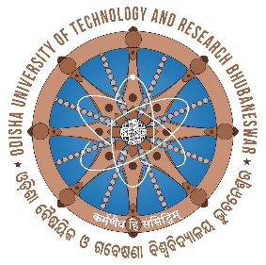
ODISHA UNIVERSITY OF TECHNOLOGY AND RESEARCH

Techno Campus, Ghatikia, P.O.- Mahalaxmi Vihar

BHUBANESWAR-751029 ODISHA, INDIA

Ref. No.09/ACD Date:05/01/2026

NOTICE

Attention: Gold and Silver Medal winners of the 3rd Annual Convocation (scheduled to be held on 19/01/2026).
_________________________________________________________________

The list of Gold and Silver Medal Winners of the 3rd Annual Convocation (scheduled date: 19.01.2026) is listed below. They are hereby instructed to fill in their details in the Google form in the link mentioned below.

Google Link: https://forms.gle/1x6NVtsRDZ1sPvEw8

The Medal Winners are required to upload all relevant details along with the photograph in the space provided for the purpose in the Google Form by 10/01/2026.

Further, they are requested to participate in the rehearsal program on 18.01.2026 wherein the Registration Kit and Convocation dress will be given at no cost. Then they will participate in the 3rd convocation on 19.01.2026 at the scheduled time for the award of medals.

Sd/-
PIC, 3rd Convocation

